

Guidance for Using Body Maps to Record Observations of Physical Injury
Where appropriate, medical assistance should be sought without delay.
Body maps are a tool to help staff accurately document and illustrate visible signs of harm or physical injury. They should be used in conjunction with the school's safeguarding recording procedures.
- Always use a black ink pen (not pencil), and do not use correction fluid or erasers.
- Do not remove clothing to examine injuries unless the area is already exposed due to treatment or the child’s clothing naturally allows visibility.
- Staff must not take photographs of any injuries or marks on a child’s body under any circumstances. Doing so may result in the staff member being subject to managing allegations procedures. Use the body map provided to record observations in line with this guidance.
- All concerns must be reported and recorded immediately to the appropriate safeguarding services, such as the Multi-Agency Safeguarding Hub (MASH) or the child’s allocated social worker if the case is already open to children’s social care.
When recording an injury, aim to include the following details for each mark observed (e.g. bruises, cuts, swelling, burns, scalds, lacerations):
- Exact location on the body (e.g. upper outer arm, left cheek)
- Size of the injury (in centimetres or inches)
- Shape of the injury (e.g. round, linear, irregular)
- Colour of the injury (note if multiple colours are present)
- Whether the skin is broken
- Presence of swelling, either at the site or elsewhere
- Any scabbing, blistering, or bleeding
- Whether the injury appears clean or contaminated (e.g. grit, fluff)
- Any restriction in mobility due to the injury
- Whether the site feels warm to the touch
- Whether the child appears feverish or in pain
- Any changes in the child’s posture or body movement
The date and time of the observation must be clearly recorded, along with the name and role of the person completing the record. Additional comments may be added where relevant.
If First Aid is administered, this should be recorded appropriately.
A completed body map should be stored securely within the child’s child protection file.
Names for child: |  | Details of physical injury:
Date of Birth: |  | Details of physical injury:
Name of worker: |  | Details of physical injury:
Signature of worker: |  | Details of physical injury:
Name of school/college: |  | Details of physical injury:
Date and time of observation: |  | Details of physical injury:
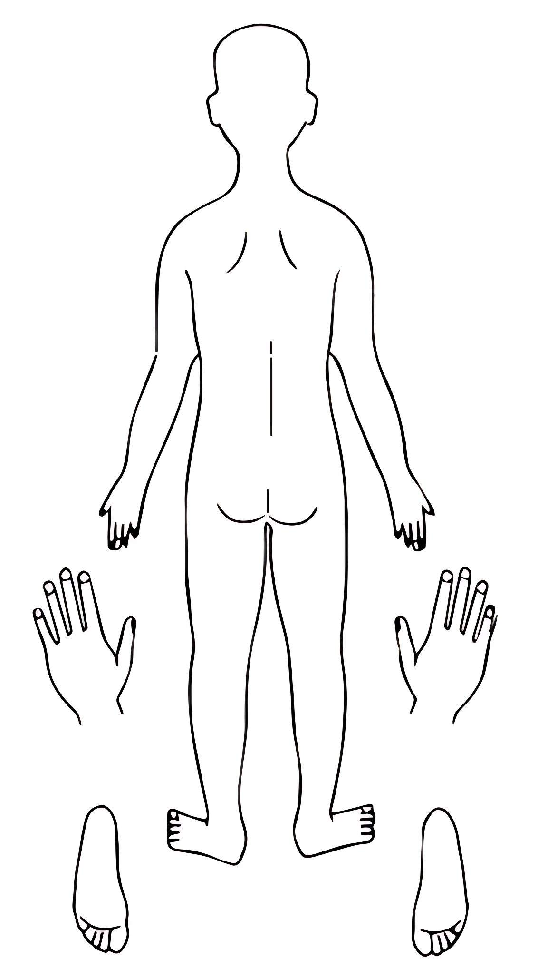
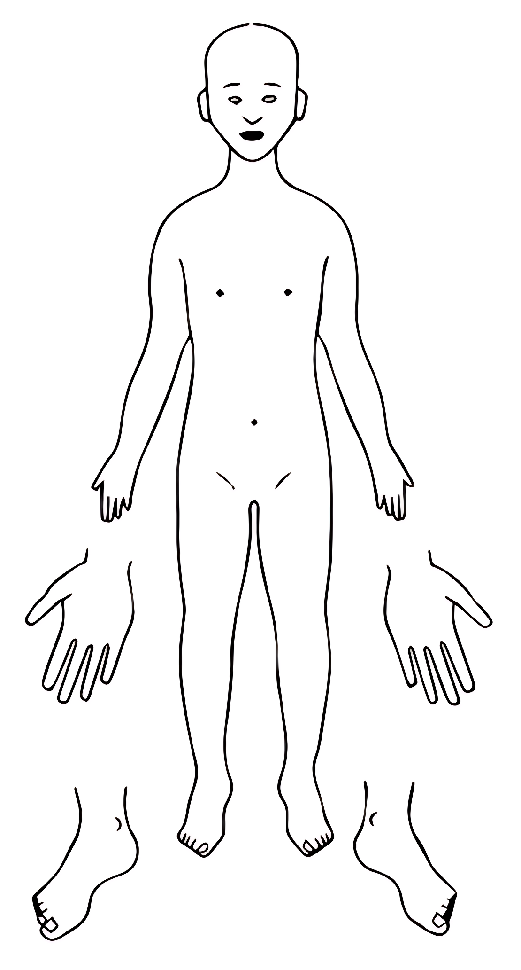
BACK
FRONT
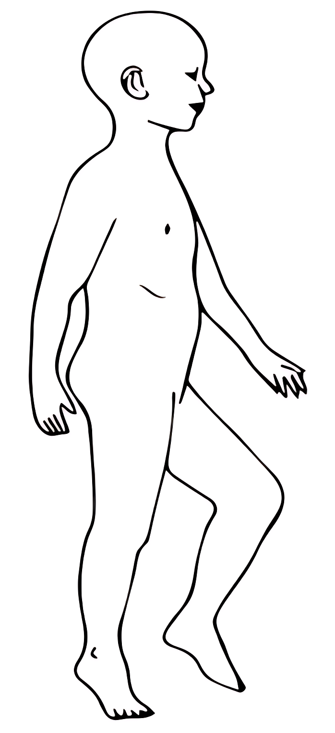
LEFT
RIGHT
Names for child: |  | Details of physical injury:
Date of Birth: |  | Details of physical injury:
Name of worker: |  | Details of physical injury:
Signature of worker: |  | Details of physical injury:
Name of school/college: |  | Details of physical injury:
Date and time of observation: |  | Details of physical injury:
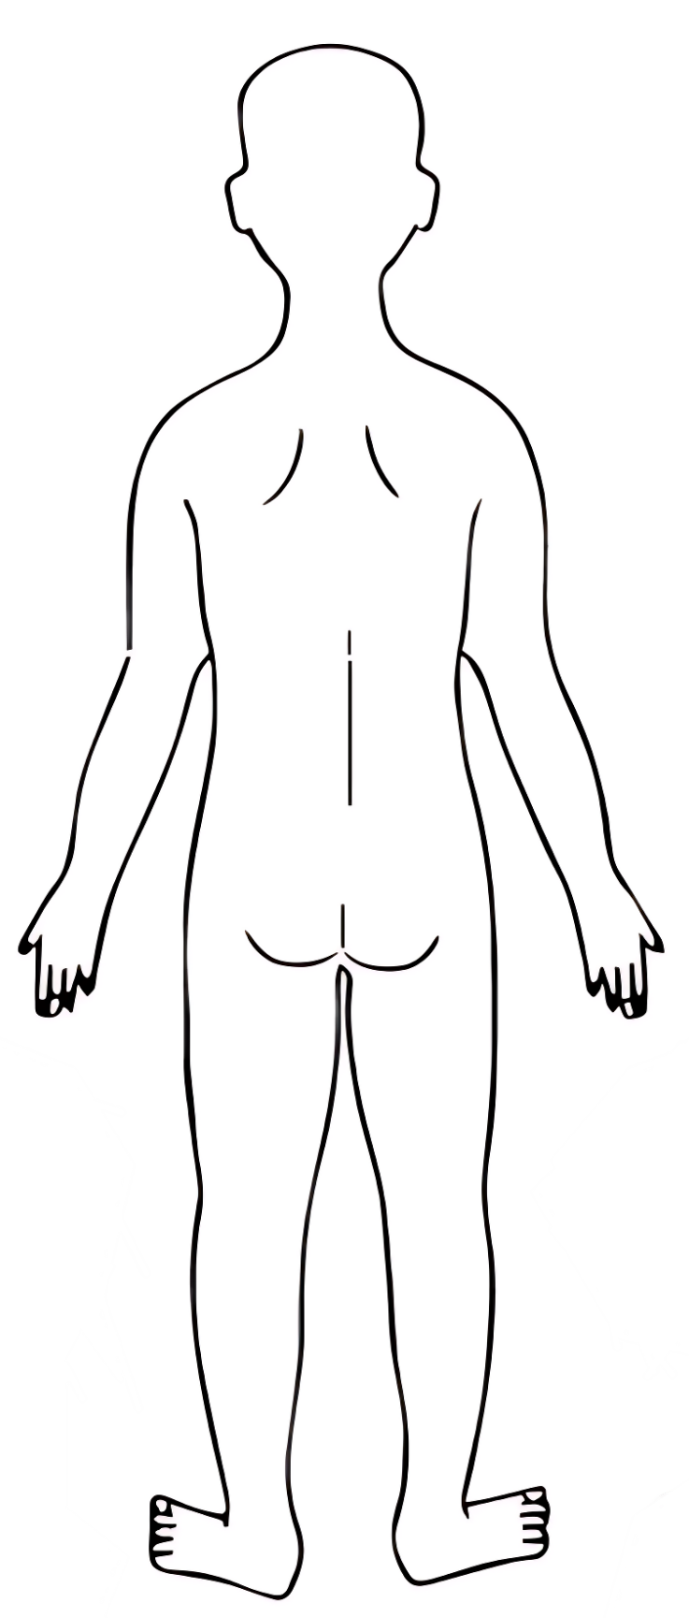
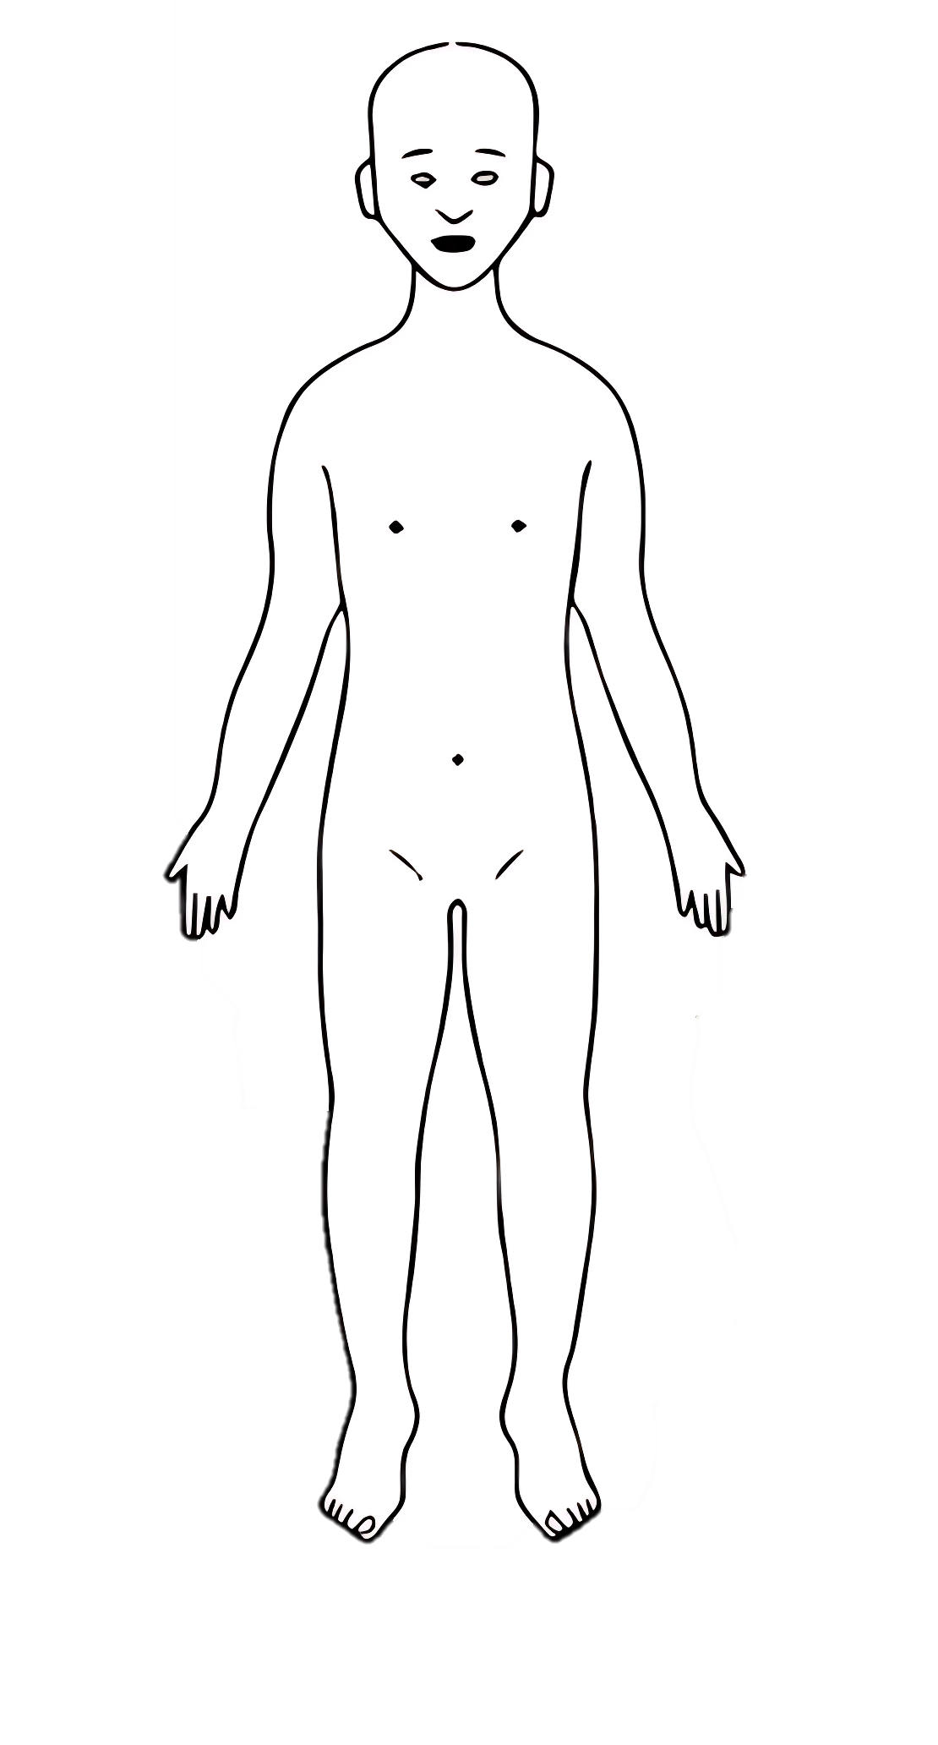
BACK
FRONT

Names for child: |  | Details of physical injury:
Date of Birth: |  | Details of physical injury:
Name of worker: |  | Details of physical injury:
Signature of worker: |  | Details of physical injury:
Name of school/college: |  | Details of physical injury:
Date and time of observation: |  | Details of physical injury:
RIGHT
LEFT

Names for child: |  | Details of physical injury:
Date of Birth: |  | Details of physical injury:
Name of worker: |  | Details of physical injury:
Signature of worker: |  | Details of physical injury:
Name of school/college: |  | Details of physical injury:
Date and time of observation: |  | Details of physical injury:
BACK OF HANDS
LEFT
RIGHT
PALMS
RIGHT
LEFT
Names for child: |  | Details of physical injury:
Date of Birth: |  | Details of physical injury:
Name of worker: |  | Details of physical injury:
Signature of worker: |  | Details of physical injury:
Name of school/college: |  | Details of physical injury:
Date and time of observation: |  | Details of physical injury:
RIGHT
LEFT
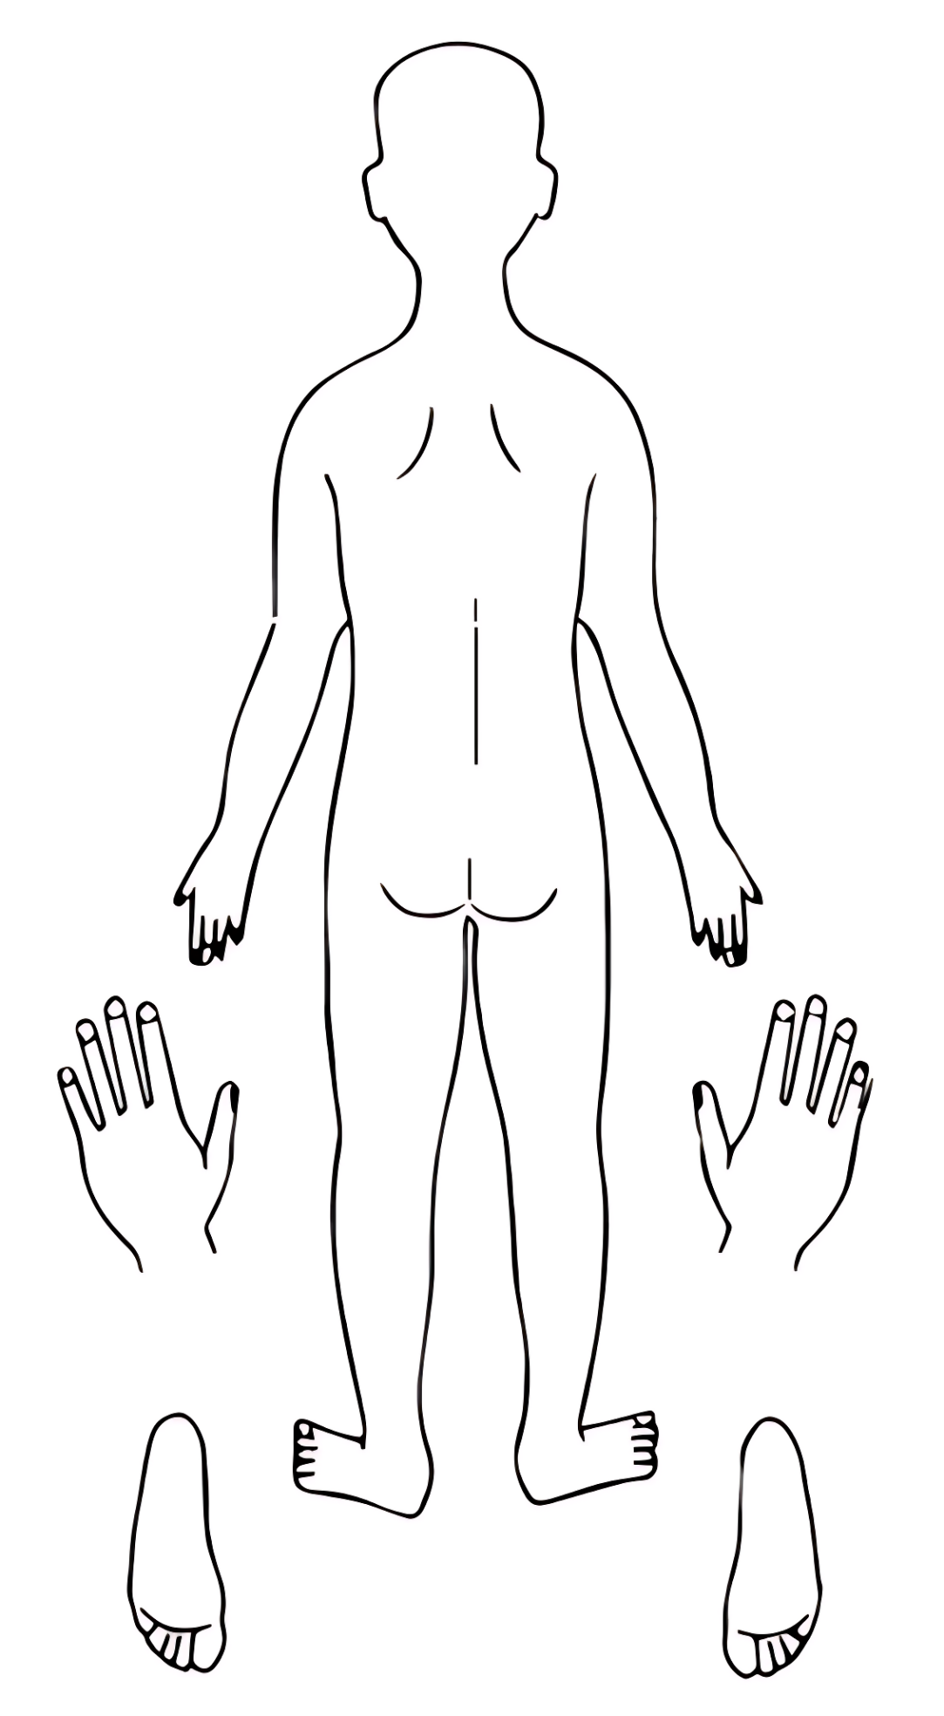
BOTTOM OF FEET
TOP OF FEET
LEFT
RIGHT

